- Visualisation
  - Appropriate graphs for the RQ output of an R script (NOT a screenshot) (50 words)

Boxplot shows that caesarean groups have same amount of lung capacity and doesn’t show large difference in middle value.

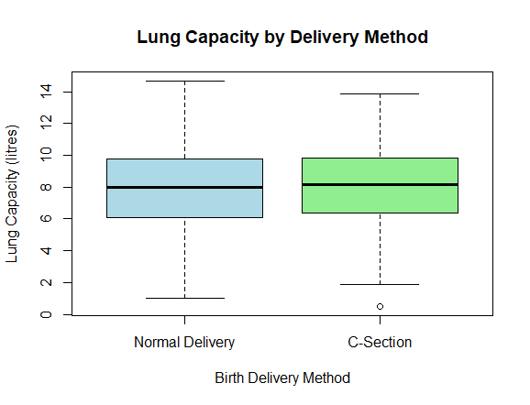

Histogram shows that the graph follows normal distribution cure. It helps us to understand the data distribution and its patten. It will also help us to select the appropriate statistical test.

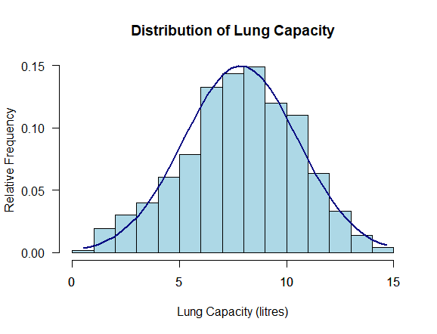

  - Additional information relating to understanding the data (optional) (50 words)

Boxplot shows similar variability in the lung capacity of two delivery methods; there is little variation in their central tendency values. Histogram shows that data is not following a normal pattern, but its smooth. Two plots work well together to provide first insight into the data pattern before performing test.

  - Useful information for the data understanding (50 words)

Mean and median values of two birth groups seem to be quite similar & shows smaller differences in the lung capacity. Histogram also indicates that values are spread out but in limitations. All these patten shows that the discrepancies in groups could be small & need statistical test for proof.

- Analysis
  - Statistical test used to test the hypotheses and output (75 words)

The independent t-test is used to find any differences for lung capacity exists in the normal and C-section deliveries. The t-test is applicable in this case because the question focuses on comparing the average values(dependent) in the two independent samples. The data in the histogram shows normally distributed curve, with the help of t-test we will be able to be determine the difference in values is because of meaningful reason or natural difference.

  - The null hypothesis is rejected /not rejected based on the p-value (100 words)

The p-value in the t-test is 0.564, which is way above the significance level of 0.05. Thus, we fail to reject the null hypothesis. We have not found evidence to prove that the value of lung capacity differs in the normal and C-section births. The variation in the averages is nothing but a matter of random chance, and the conclusion to be derived is that the type of delivery has nothing to do with the capacity of the lungs in this sample, however the difference in lung capacity can be because of many other known or unknown reasons.

- Reference list (not included in the word count)
Harvard (author, date) format.

Dojo Staff, D.S. (2022). 7 Types of Statistical Distributions with Practical Examples. Datasciencedojo. Available at: https://datasciencedojo.com/blog/types-of-statistical-distributions-in-ml/ [Accessed 7 Dec. 2025].

- Appendices

library(readr)
library(readxl)

LungCapData <- read_csv("LungCapData.csv")
View(LungCapData)

#reading columns and rows
colnames(LungCapData)
nrow(LungCapData)

#Changing Caesarean from yes & no to C-Section & Normal Delivery
LungCapData$Caesarean[is.na(LungCapData$Caesarean)] <- "no"

LungCapData$Caesarean[LungCapData$Caesarean == "no"] <- 0
LungCapData$Caesarean[LungCapData$Caesarean == "yes"] <- 1

LungCapData$Caesarean <- as.numeric(LungCapData$Caesarean)

LungCapData$Caesarean <- factor(
LungCapData$Caesarean,
levels = c(0, 1),
labels = c("Normal Delivery", "C-Section")
)

#Reading updated rows
table(LungCapData$Caesarean)
table(LungCapData$Smoke)
table(LungCapData$Gender)

#reading first 5 rows
head(LungCapData, 5)

#Analyzing bit
summary(LungCapData$LungCap)
summary(LungCapData$Caesarean)
sd(LungCapData$LungCap)
sd(LungCapData$Age)
mean(LungCapData$LungCap)
median(LungCapData$LungCap)

# Mean of Lung Capacity by delivery method
aggregate(LungCap ~ Caesarean, data = LungCapData, FUN = mean)

# Median of Lung Capacity by delivery method
aggregate(LungCap ~ Caesarean, data = LungCapData, FUN = median)

#Boxplot (comparison of means)
boxplot(LungCap ~ Caesarean,
data = LungCapData,
main = "Lung Capacity by Delivery Method",
xlab = "Birth Delivery Method",
ylab = "Lung Capacity (litres)",
col = c("lightblue", "lightgreen"))

#Histogram (comparison of means)
hist(LungCapData$LungCap,
prob = T,
breaks=20,
xlab = "Lung Capacity (litres)",
ylab = "Relative Frequency",
main = "Distribution of Lung Capacity",
col = "lightblue",
las = 1)
axis(side = 1
)
x <- seq(min(LungCapData$LungCap), max(LungCapData$LungCap), length = 40)
f <- dnorm(x, mean = mean(LungCapData$LungCap), sd = sd(LungCapData$LungCap))
lines(x, f, col = "navy",lwd=2)

#Independent samples t-test (parametric)
t_test_result <- t.test(LungCap ~ Caesarean,
data = LungCapData,
paired = FALSE)
t_test_result

#p value
t_test_result$p.value

- GitHub log output.

commit 1595e8d4f36ffa7d28164a1564c415c0c046e81c
Author: dp18abz <115548394+dp18abz@users.noreply.github.com>
Date: Thu Dec 11 15:46:47 2025 +0000

added git log output

commit 8fd40d7a3513fe90c1c5157b6c482b43c51b94af
Merge: b61339a c8edad2
Author: dp18abz <115548394+dp18abz@users.noreply.github.com>
Date: Thu Dec 11 15:31:03 2025 +0000

Merge pull request #1 from nk25abx/dp18abz-patch-1

GraphAdd- Boxplot and histogram

commit b61339af845a6f201908770086938826712afe6c
Author: dp18abz <115548394+dp18abz@users.noreply.github.com>
Date: Thu Dec 11 15:28:09 2025 +0000

lungcapacity- final-Rfile

All updates have been completed; meaningful comments were added, and suitable plots were adjusted.

commit 8531c7671abdd5a255efa5767611cf51a1835e5e
Author: dp18abz <115548394+dp18abz@users.noreply.github.com>
Date: Thu Dec 11 14:31:45 2025 +0000

Adding Dataset

commit c8edad23c0ea30b4f293e226c34a3480c99af572
Author: dp18abz <115548394+dp18abz@users.noreply.github.com>
Date: Thu Dec 11 14:20:48 2025 +0000

Add files via upload

commit 77a5377d8e057a15c1dfacc34483fb84a5c779bd
Author: dp18abz <115548394+dp18abz@users.noreply.github.com>
Date: Tue Dec 9 15:35:27 2025 +0000

Add files via upload

commit a98bede079cb56c0f56e84907e37e831cdd45e78
Author: NOOR <nk25abx@herts.ac.uk>
Date: Sun Dec 7 14:08:29 2025 +0000

Added full Code

commit ec329cc0b24adfab1dec5275d9493c376c1368c8
Author: NOOR <nk25abx@herts.ac.uk>
Date: Sun Dec 7 13:40:29 2025 +0000

Added Code

commit cb99e73a29ce2c827d6e29748ac467f5328c10be
Author: NOOR <nk25abx@herts.ac.uk>
Date: Sun Dec 7 13:26:01 2025 +0000

Followed Template 2

commit 844c3a4fcc6ff33394a74e27630759e886b2b852
Author: NOOR <nk25abx@herts.ac.uk>
Date: Sun Dec 7 13:02:17 2025 +0000

Added Dependent and Independent Variables

commit 35869f2a3fe32dc763783e3d08366c726c0c7ca5
Author: NOOR <nk25abx@herts.ac.uk>
Date: Sun Dec 7 12:57:12 2025 +0000

Added Research Question

commit c7f231459838a6bab8ba54d43a03fb08db03f670
Author: NOOR <nk25abx@herts.ac.uk>
Date: Sun Dec 7 12:54:03 2025 +0000

My third commit

commit 8b8ee3deee21ec8dcf58c0917f3f2ba536fb86e6
Author: NOOR <nk25abx@herts.ac.uk>
Date: Sun Dec 7 12:51:27 2025 +0000

My second commit

commit 5c5bc770d8c3b1b7a8f7a7ffe86f91a4fd0f9c25
Author: NOOR <nk25abx@herts.ac.uk>
Date: Sun Dec 7 12:41:17 2025 +0000

My first Commit

